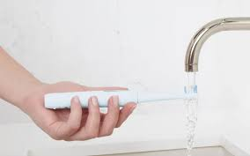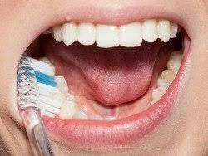

Get toothbrush wet Put toothpaste on toothbrush Brush bottom left teeth for 20 seconds (make sure to brush your gums)

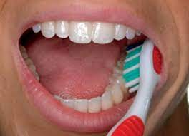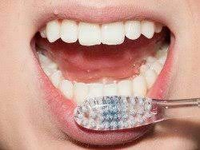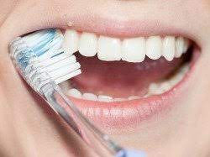

Brush bottom right teeth for 20 seconds Brush bottom center teeth for 20 seconds Brush top left teeth for 20 seconds

(make sure to brush your gums) (make sure to brush your gums) (make sure to brush your gums)

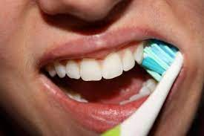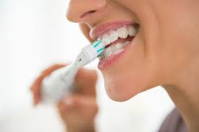

Brush top right teeth for 20 seconds Brush top middle teeth for 20 seconds Rinse mouth and

(make sure to brush your gums) (make sure to brush your gums) wipe face